Pv bosch

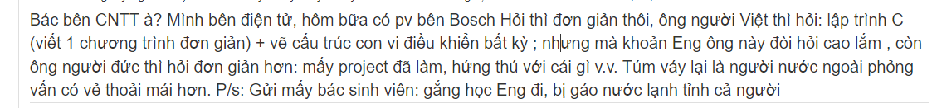

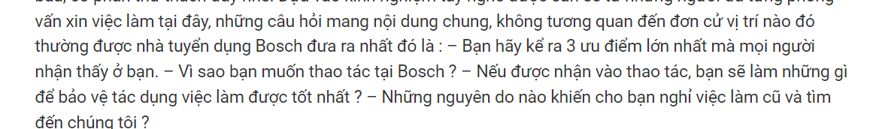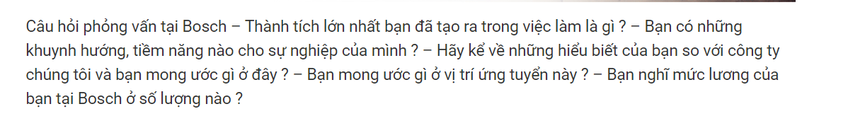

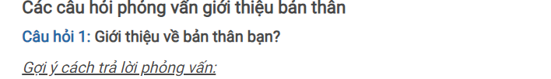

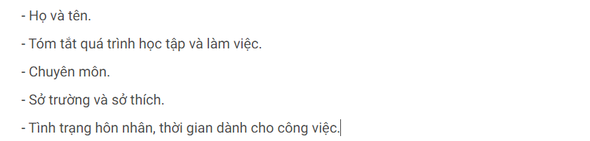

"My name is Trinh Dinh Phi. Currently, I am a fourth-year student at the Ho Chi Minh City University of Technology and Education, majoring in Computer Engineering technology”

the skills I have cultivated at school include knowledge in embedded programming, IoT with Python, computer architecture, RTOS, and embedded programming. I believe these skills can contribute in a small way to addressing significant challenges within the company. Additionally, I am an energetic and passionate student with a positive attitude towards learning, constantly striving to enhance the skills that the company desires me to improve."

Câu 2: em thich môn học nào nhất

"I particularly enjoy C programming and embedded systems as well as IoT because C programming has helped me develop the ability to control and optimize system memory, while embedded systems and IoT open doors to creating smart applications, connecting, and optimizing devices in our daily lives. I am excited about the boundless potential of these fields and look forward to the opportunity to apply my knowledge to make positive and meaningful changes in both work and life."

Câu 3 : em muốn môi trường làm việc như thế nào

"I aspire to work in a dynamic, creative environment that offers ample opportunities for personal growth, where people are cheerful, cooperative, and genuinely care for one another. I believe Bosch is a fitting place for me as I read an article and learned that the company consistently fosters employee development, happiness, and motivation, accompanied by various benefits. I am excited and committed to working diligently to contribute my skills and efforts to the company."

Câu 4: tại sao chọn Bosch

"Bosch is a renowned company in the field of embedded systems and IoT. Moreover, the working environment for employees is always emphasized, promoting creativity, and fostering the development of individuals, along with numerous excellent benefits. Therefore, I believe this is an ideal internship environment for me to enhance my skills in embedded programming and gain valuable knowledge."

**Câu 5 giới thiệu đồ án**

"My project aims to build an automated irrigation system for coffee plant with the ability to control water, misting system irrigation based on temperature and humidity conditions. It includes water irrigation control through a mobile app, as well as sending collected data to Firebase for monitoring and analysis. Additionally, a mobile app is developed to allow users to monitor and manually toggle the water irrigation and misting system as desired."

**Dùng 1 từ miu tả bản thân**

I chose the word 'dedicated' because I always strive to put in my best effort and be devoted to completing assigned tasks."

Câu 6 gặp khó khăn j trong dự án

"Interacting with Firebase:

Challenge: Sending and receiving data from Firebase can be challenging when dealing with special cases such as lost connections, data access errors, or data sending failures. Solution: Use conditional statements to check the results of Firebase interactions and handle errors appropriately, such as retrying the connection or displaying error messages."

**Câu 7 : cach hoạt động của dự án :**

"How the code works in basic terms:

Connecting to Wi-Fi and Firebase:

The code begins by connecting the device to a Wi-Fi network and then establishes a connection to a Firebase project using the configured Wi-Fi credentials (WIFI_SSID and WIFI_PASSWORD) and Firebase authentication information (FIREBASE_HOST and FIREBASE_AUTH). Setting up Sensors and Relays:

The pins for the temperature and humidity sensor (DHTPIN and DHTTYPE) are configured. The pins for the relays used to control irrigation and misting (relaydat and relaykk) are configured. The Loop:

In the loop() function, the code runs continuously and performs the following operations: Reading Data from Firebase:

The code reads data from Firebase, including the mode and the state of the relays (relaydat and relaykk), through the firebaseData variables. Reading Data from Sensors:

The code reads data from the temperature and humidity sensor and calculates their average. Then, it converts the values to percentages (phantramthuc). Controlling Relays:

Based on the data read from Firebase (mode, relaydat, relaykk) and the sensor readings (phantramthuc, t1), the code decides when to turn on or off the relays for irrigation and misting. Sending Data to Firebase:

The code sends temperature and humidity data to Firebase for monitoring and analysis. Looping:

Finally, the code waits for a period of time (500ms) and then repeats the process."

JUNIOR EMBEDDED SOFTWARE ENGINEER t

Câu 8 dự án đếm người

